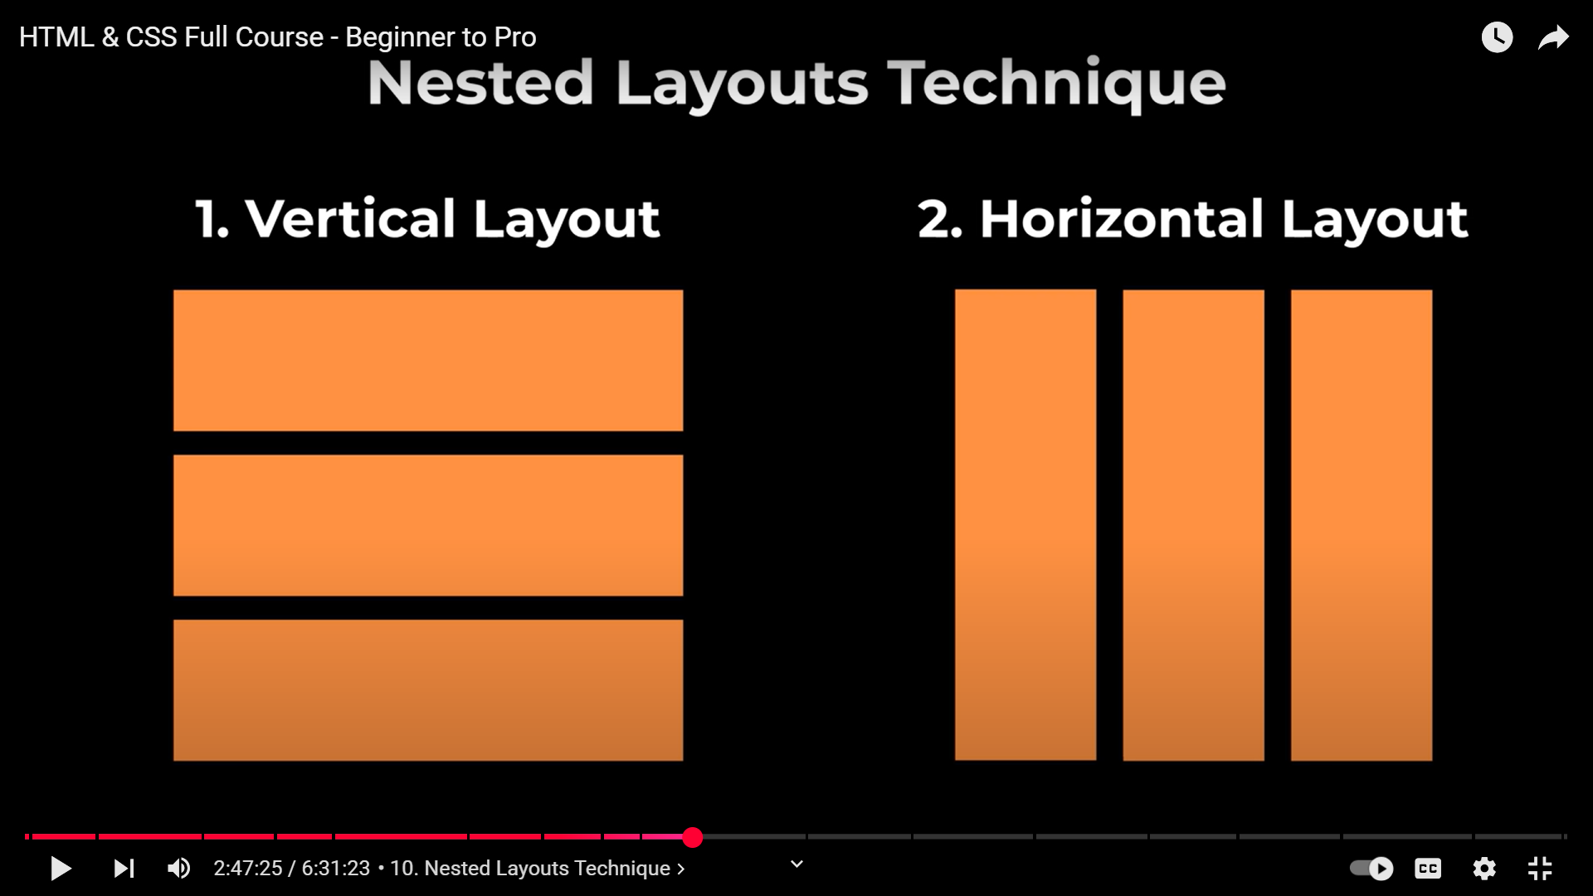  
**VERTICAL LAYOUTS ARE WHERE THE LAYERS ARE STACKED ON TOP OF ANOTHER!!!!!!!!!!!!  
HORIZONTAL LAYOUTS ARE WHERE THE LAYERS ARE STACKED BESIDE EACH OTHER!!!!!!!!!!!!!!!!!!**  
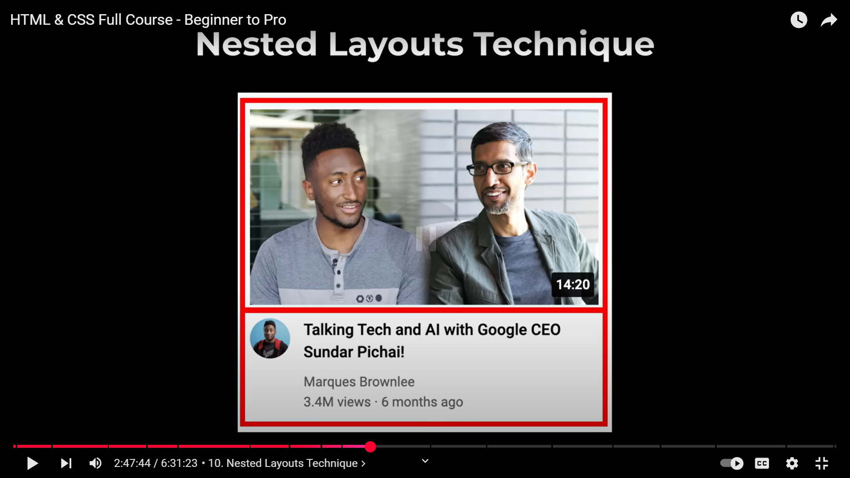  
  
  
  
  
Vertical layout  
  
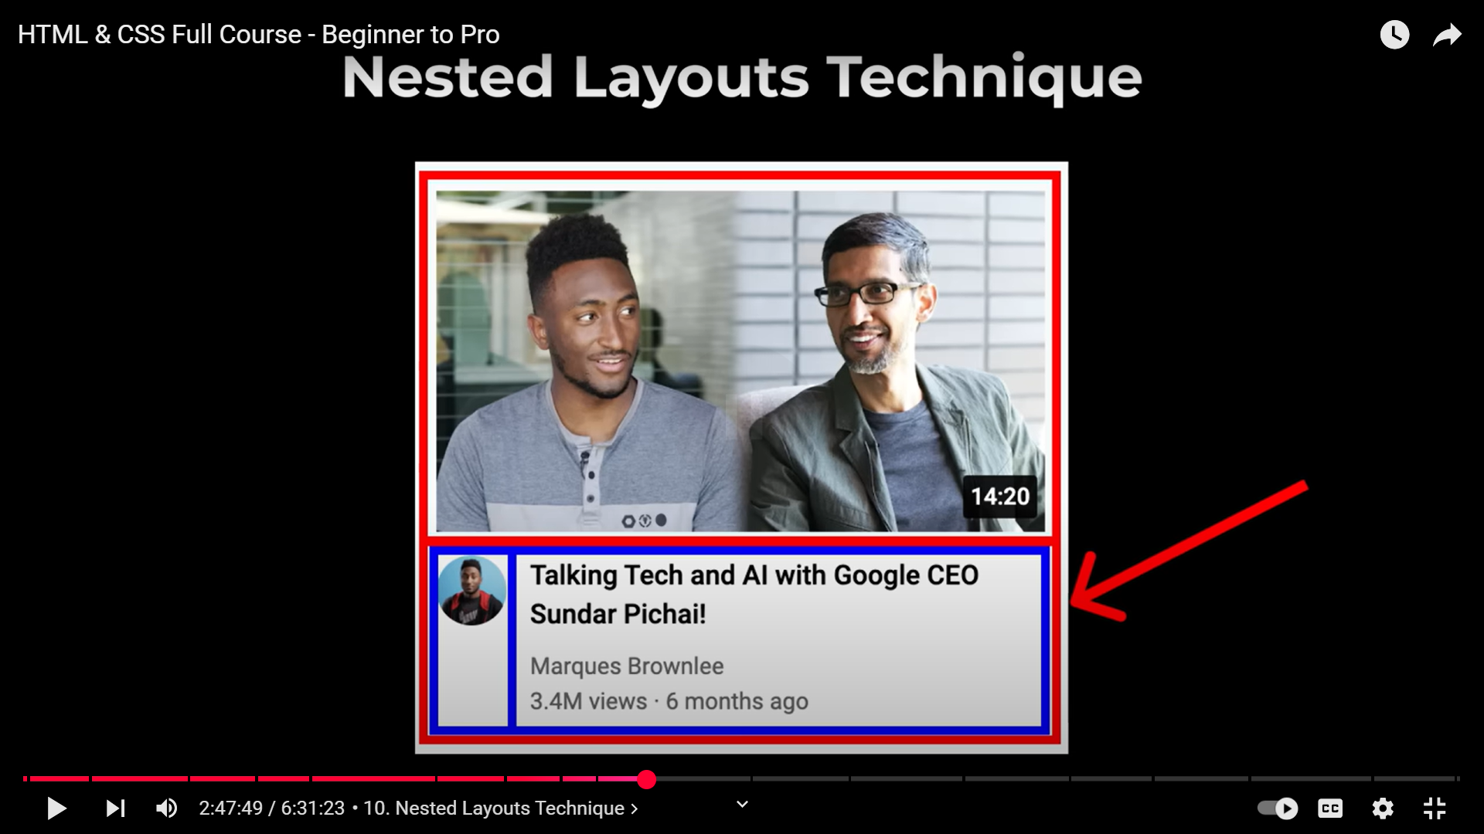  
Horizontal Layout  
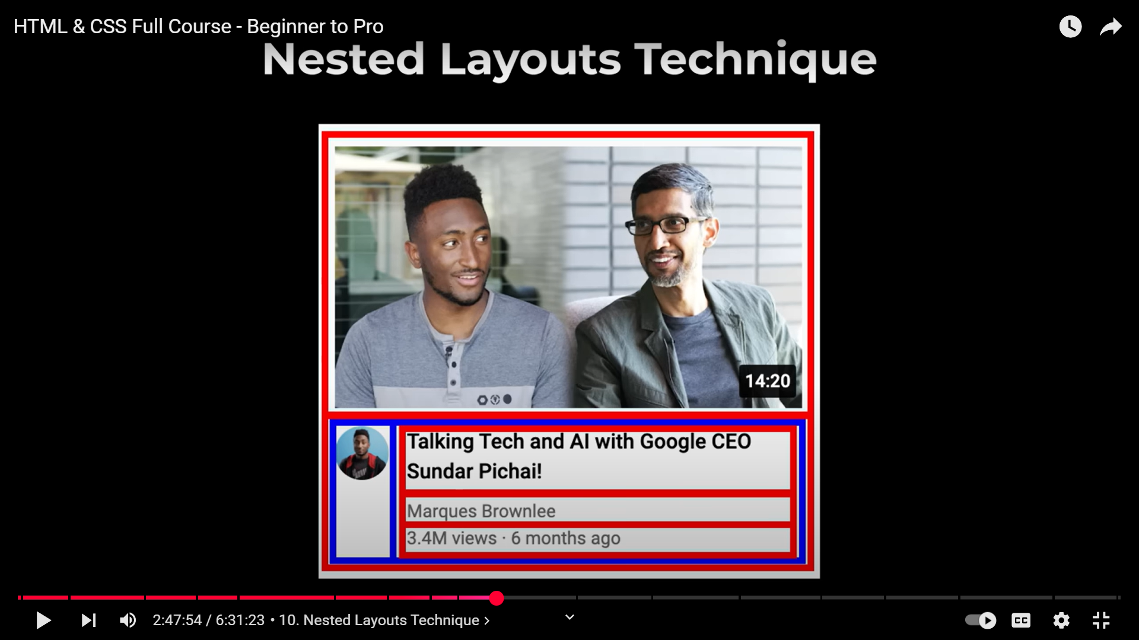  
Vertical layout again  
  
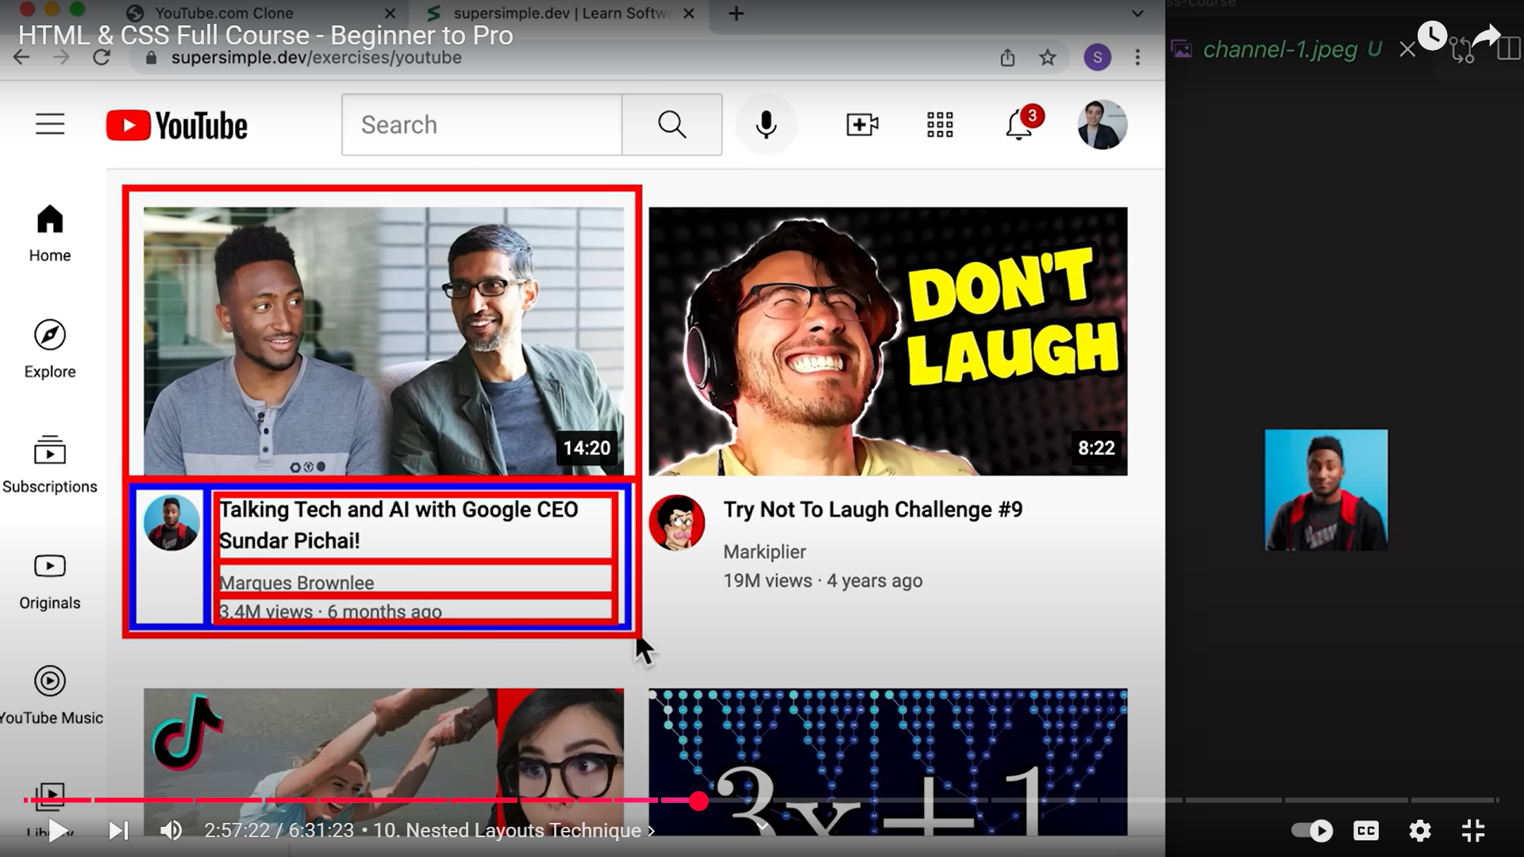  
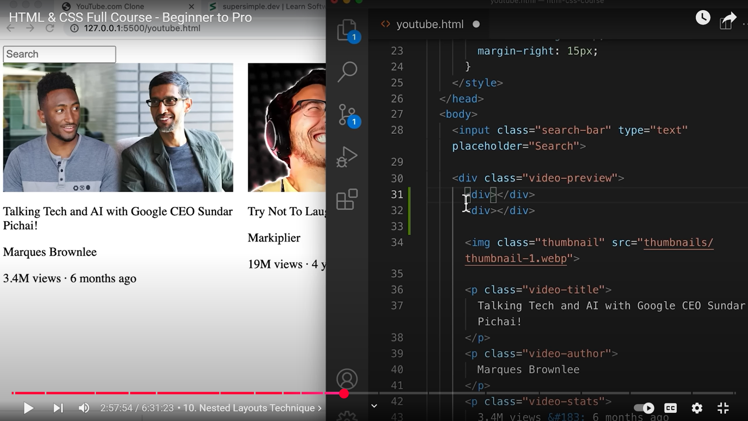  
31 and 31 are the vertical layouts  
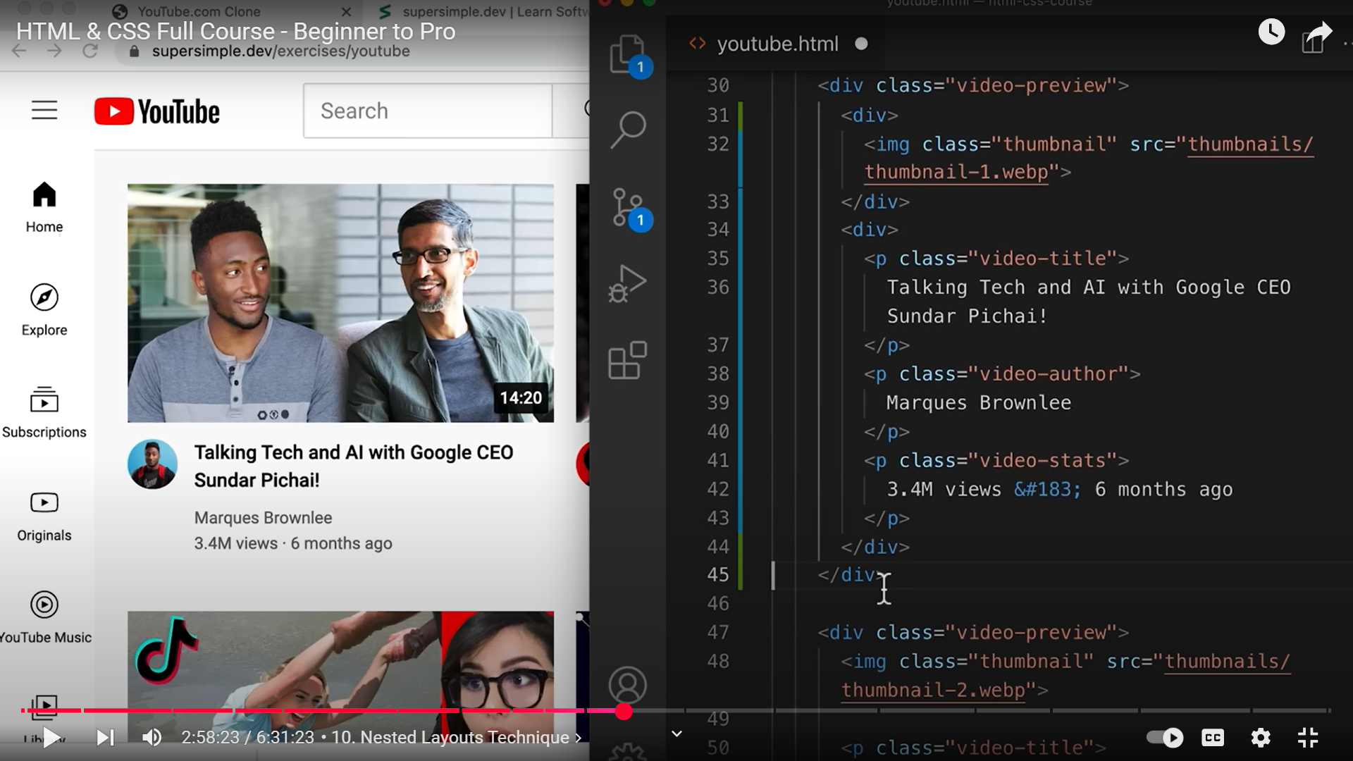  
31 to 33 first vertical layout  
34 to 44 second vertical layout  
  
  
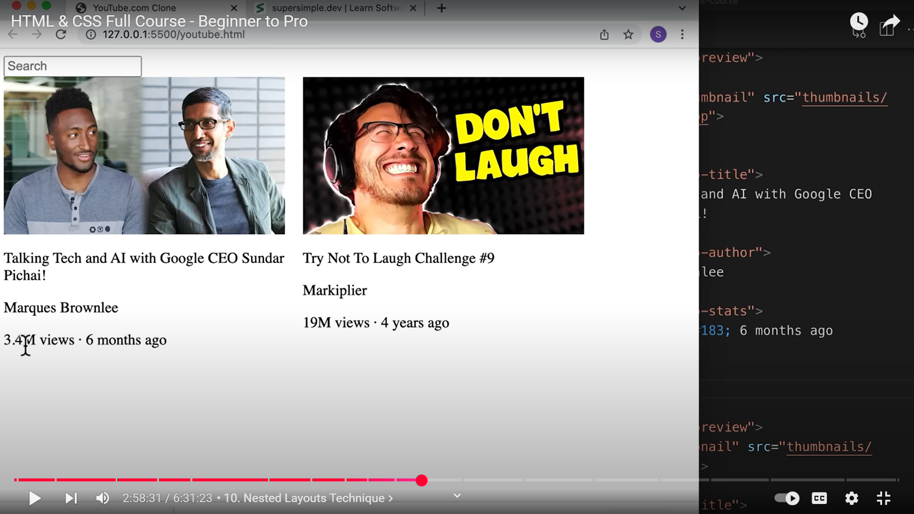Next horizontal layout  
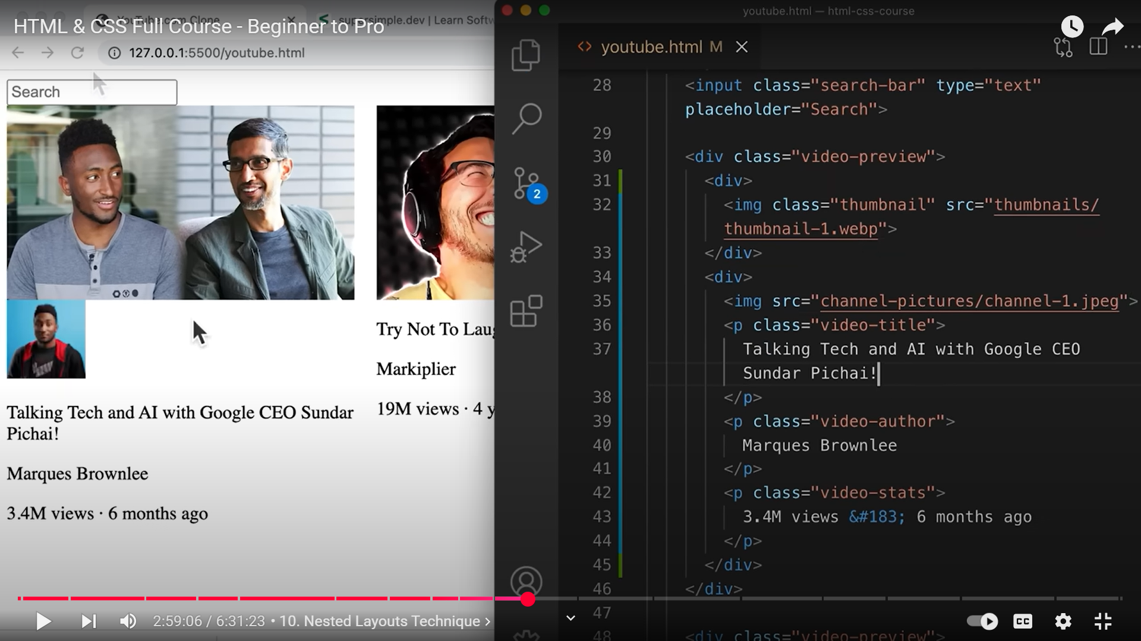  
35

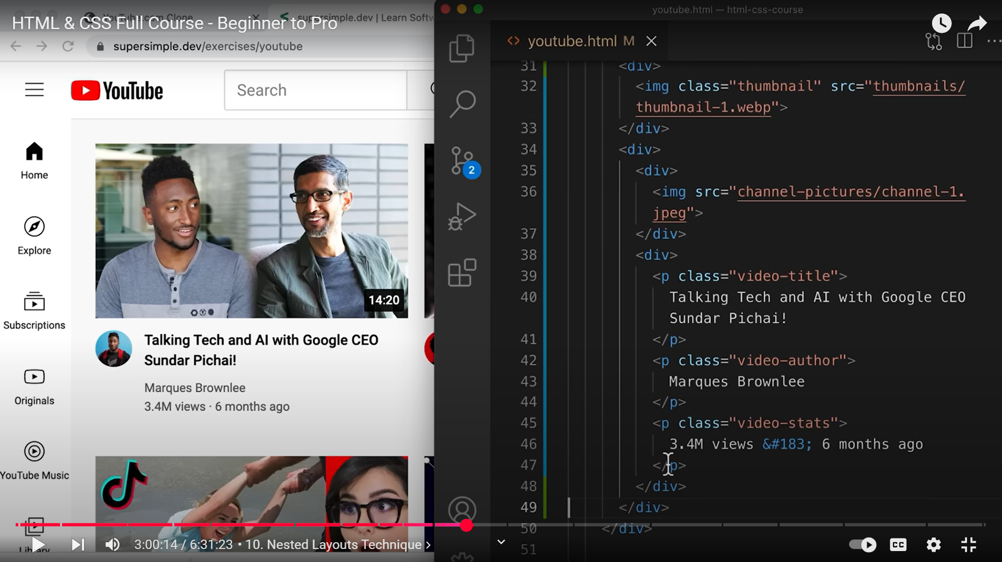  
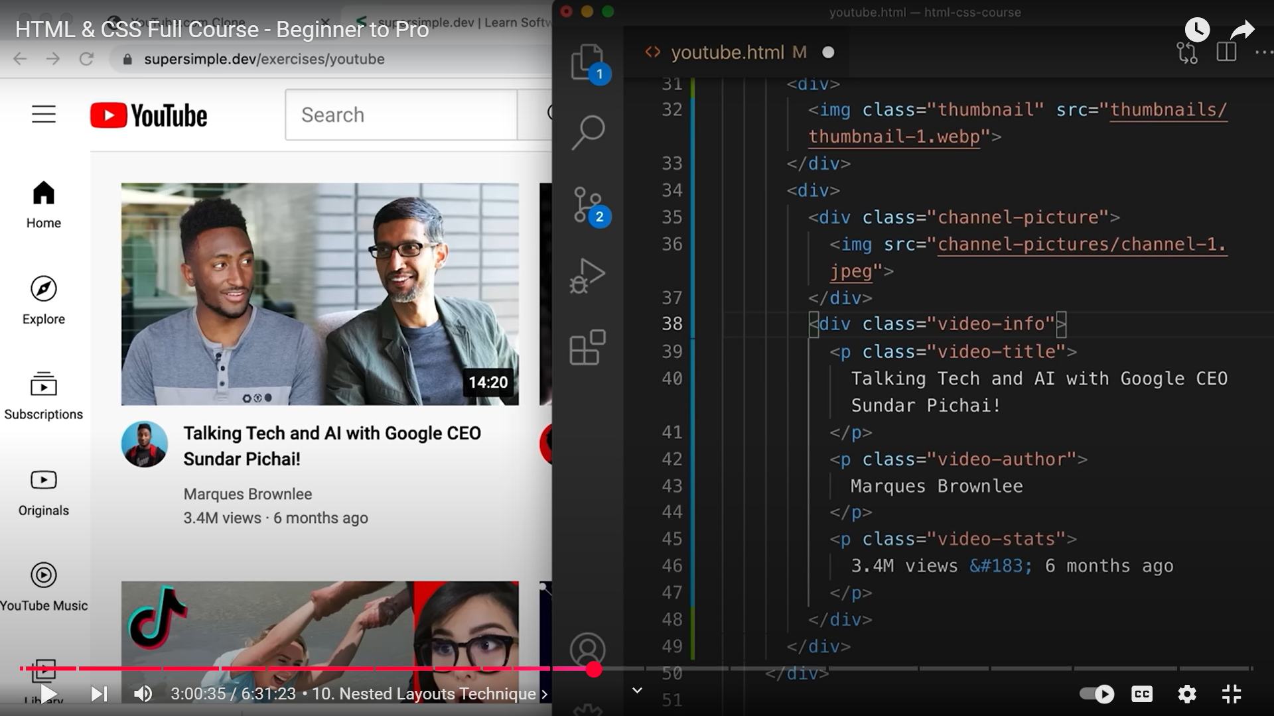  
35,38  
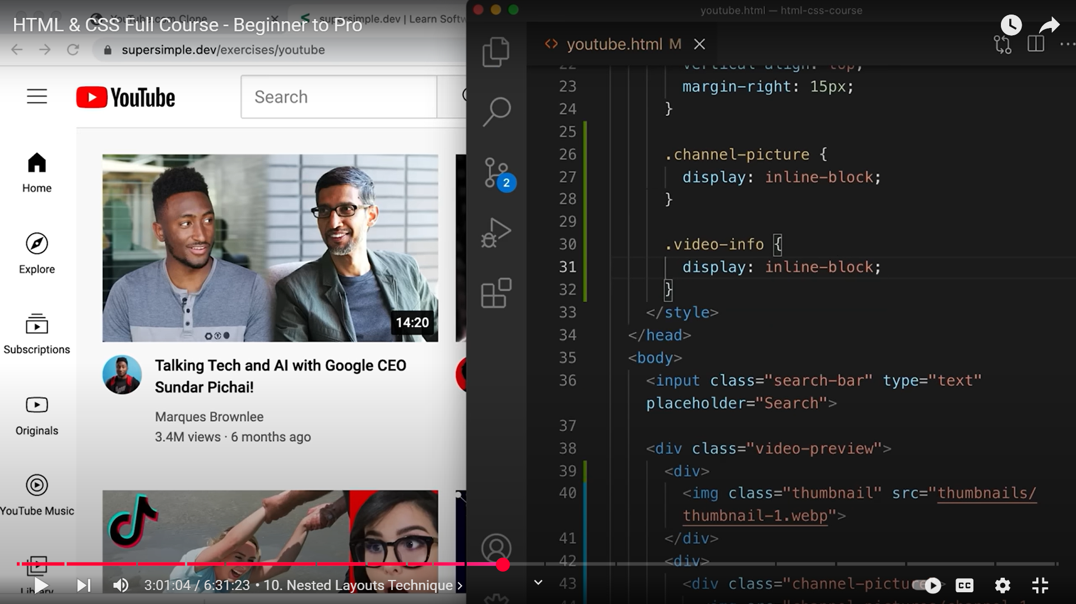  
26,30  
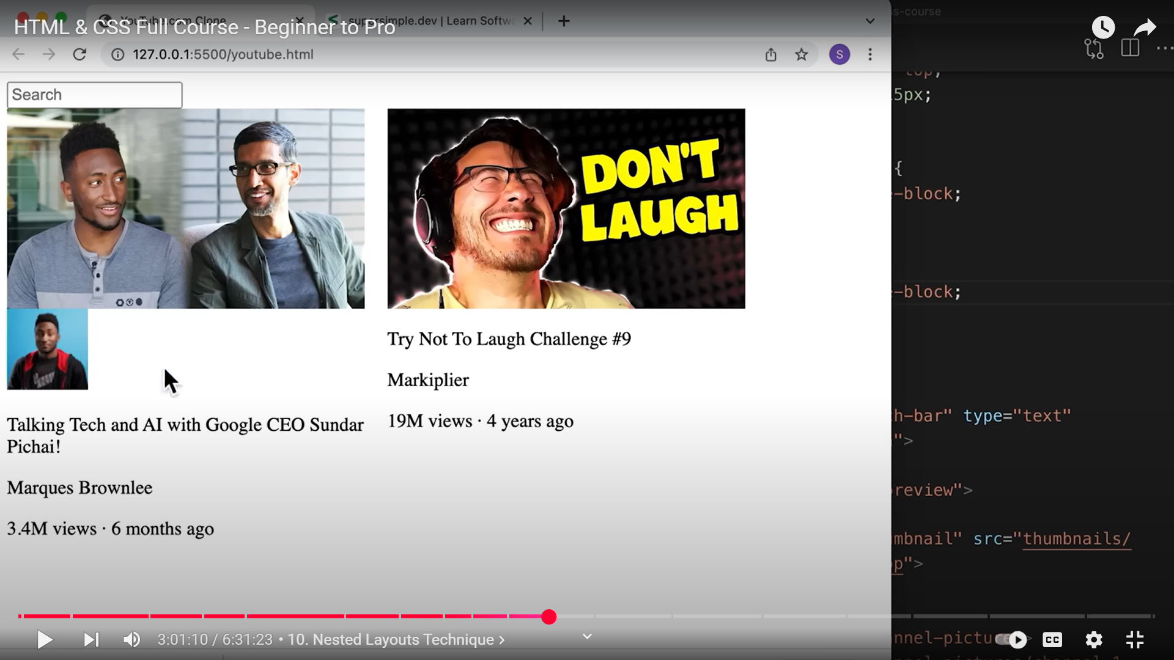  
Still on top of each other as div has a default width of 100%  
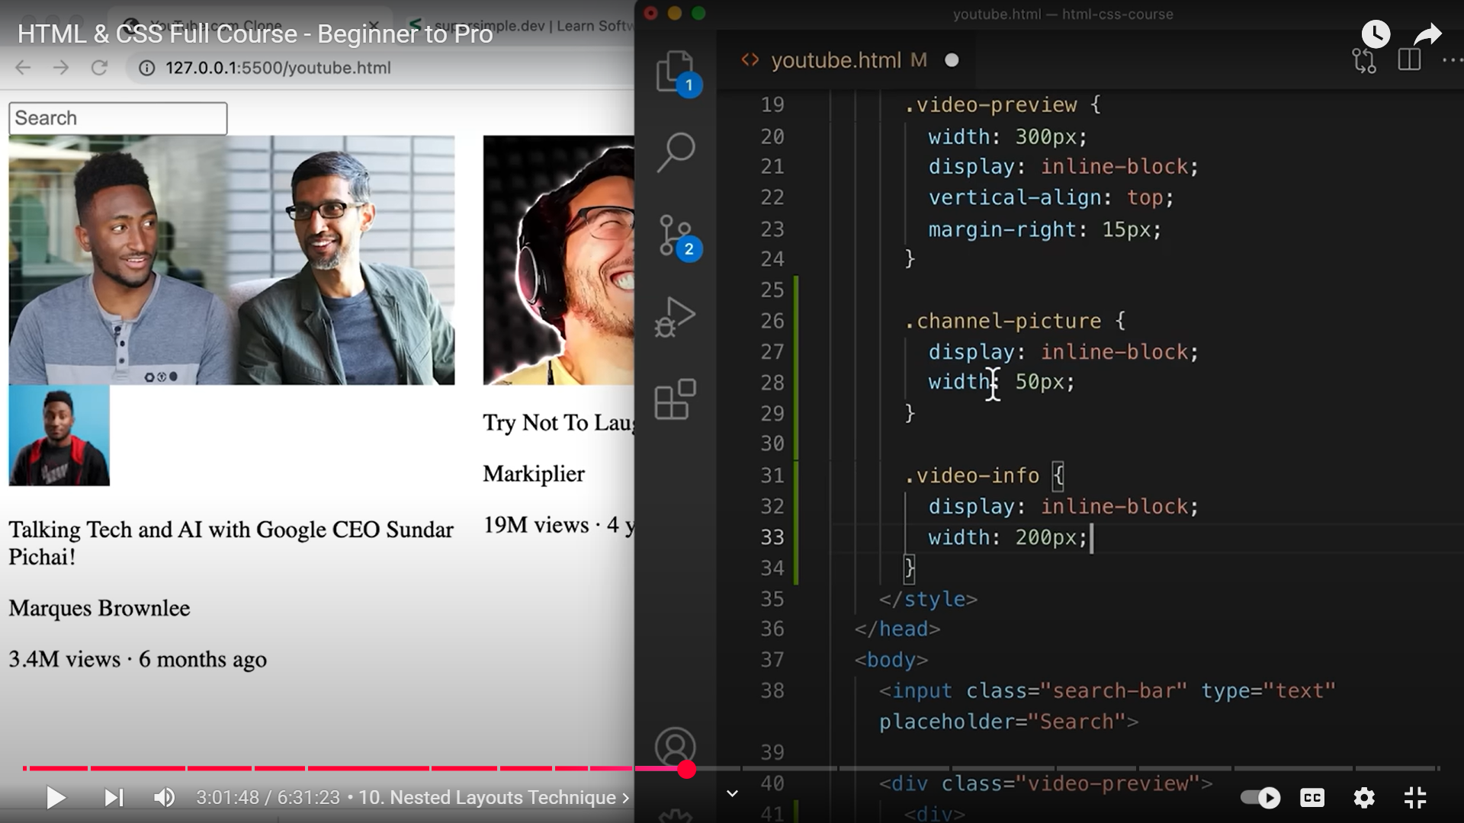  
28,33  
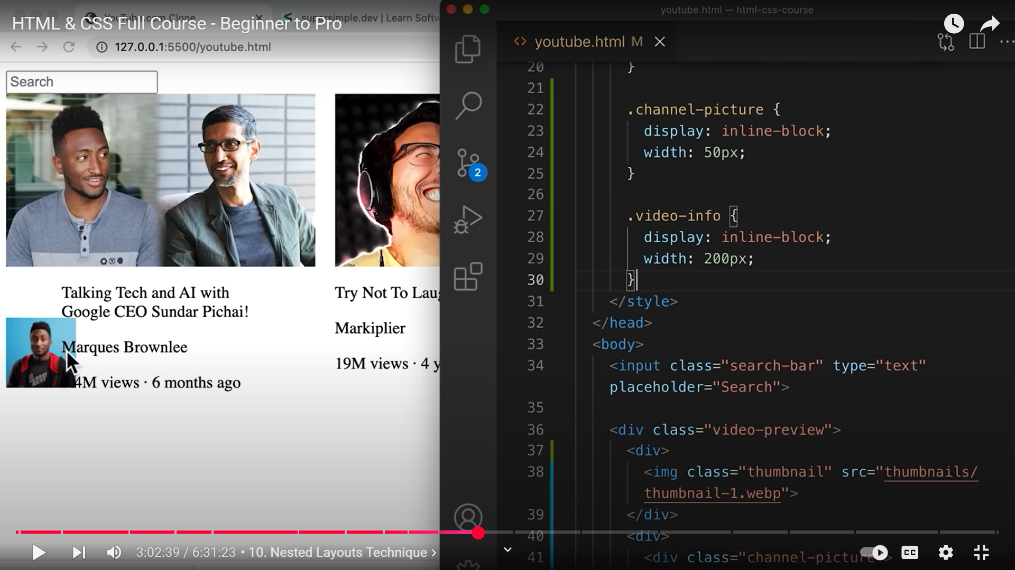  
**IMAGES(HERE CHANNEL PROFILE PICTURE) OVERFLOW BY DEFAULT TO KEEP THEIR ORIGINAL DIMENSIONS. WE WANT TO RESIZE THE IMAGE, SO THAT IT TAKES UP ONLY 50PX(LINE 24).**

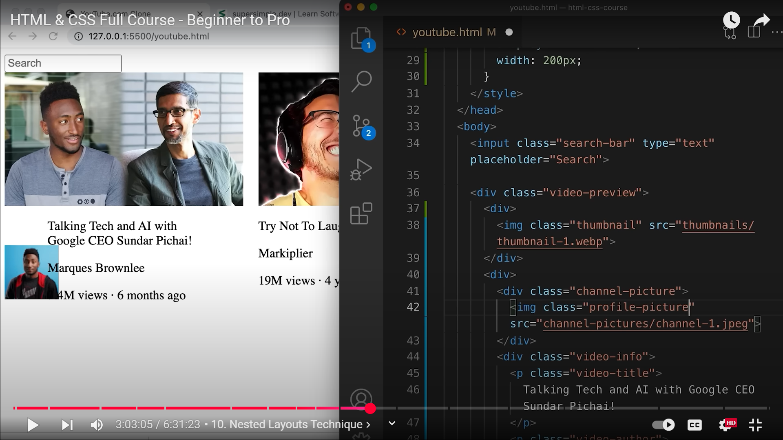  
Adding profile-picture class at 42.  
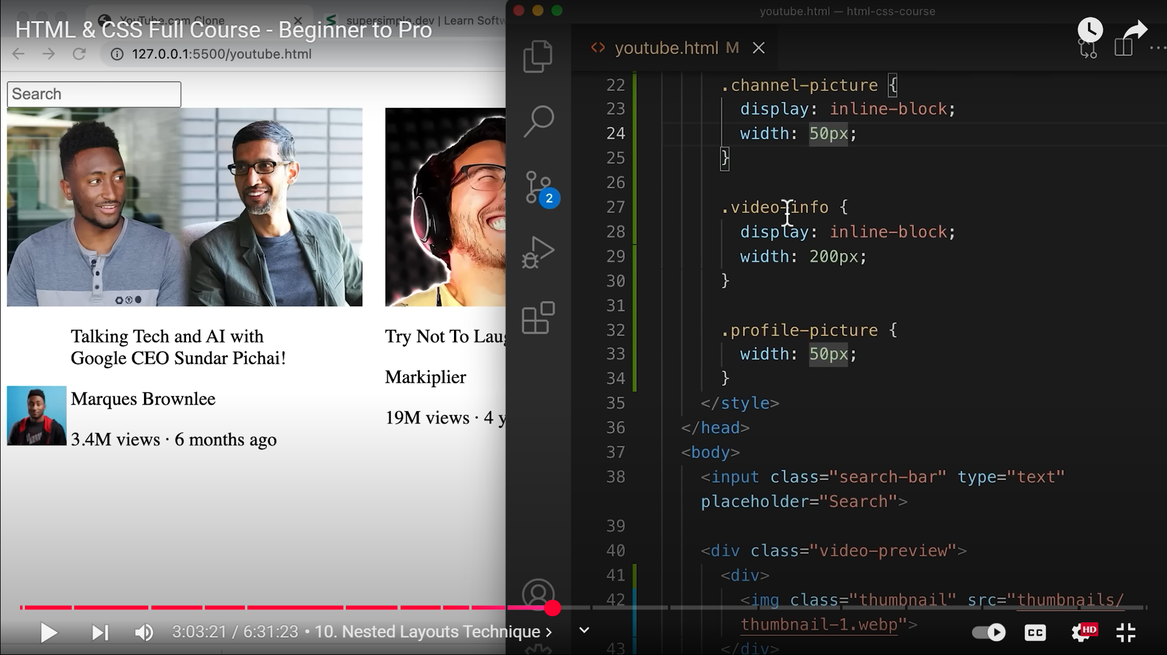  
32  
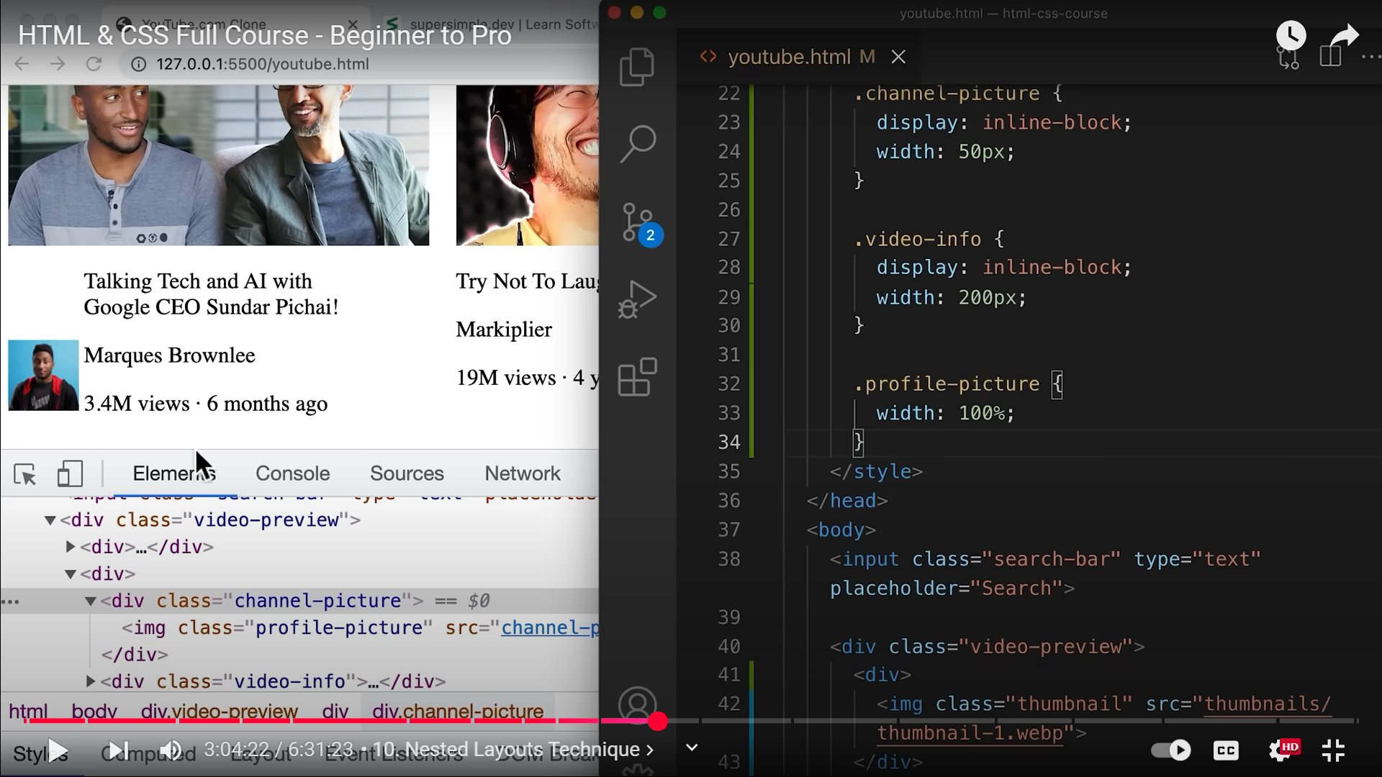  
33  
  
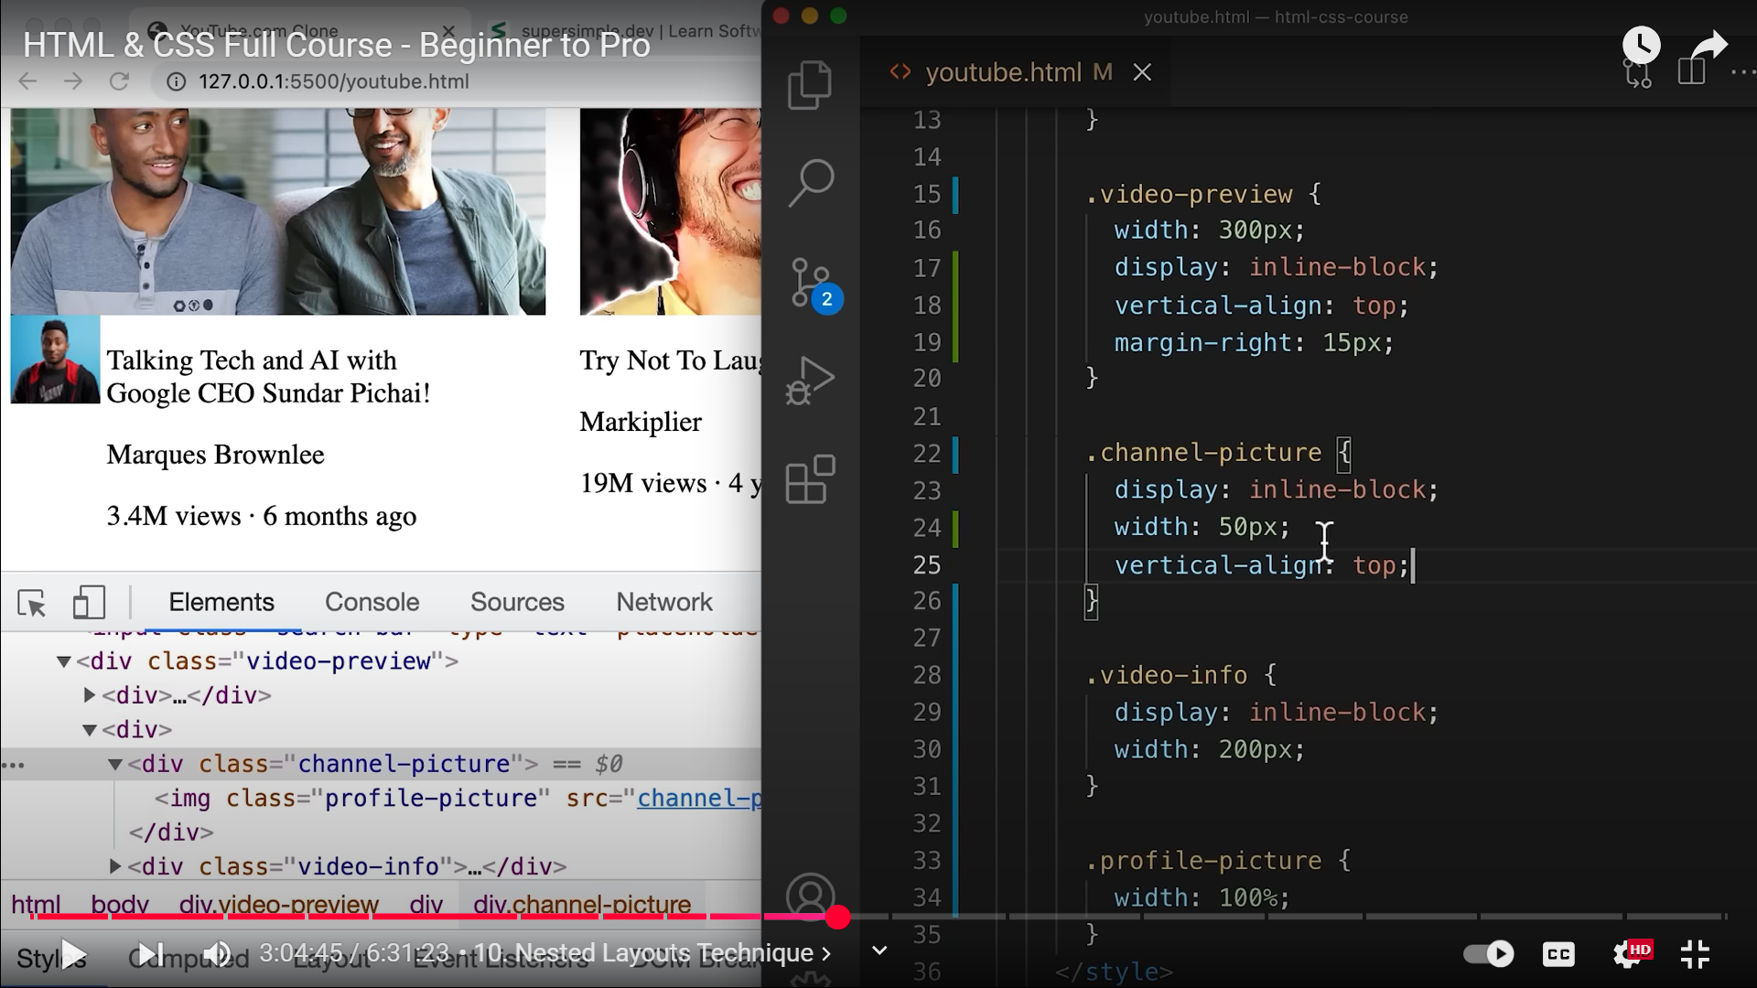  
25  
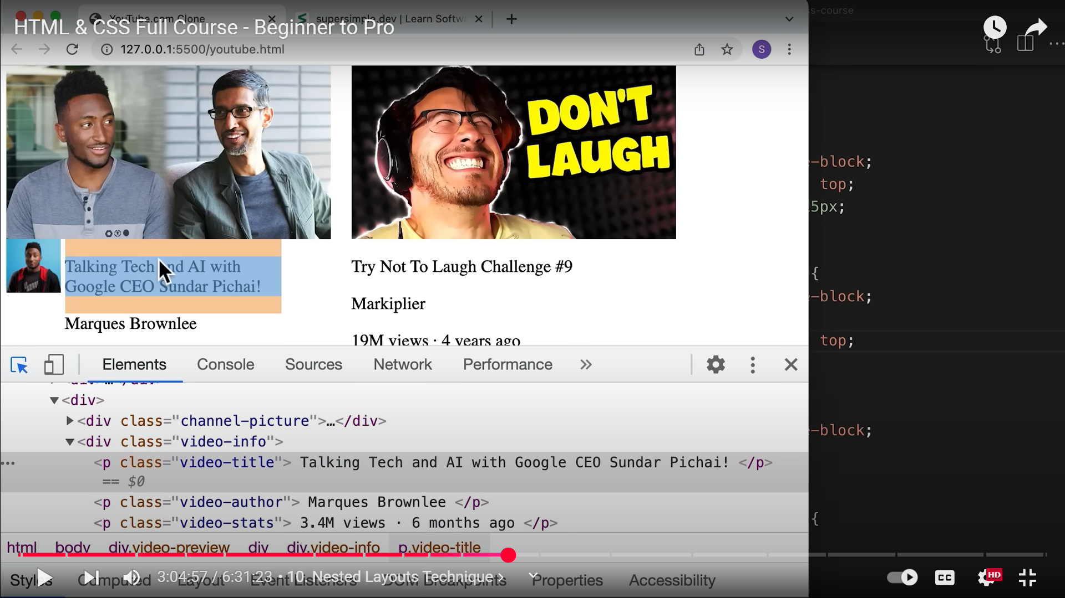  
Have to get rid of the margin at the top and bottom.  
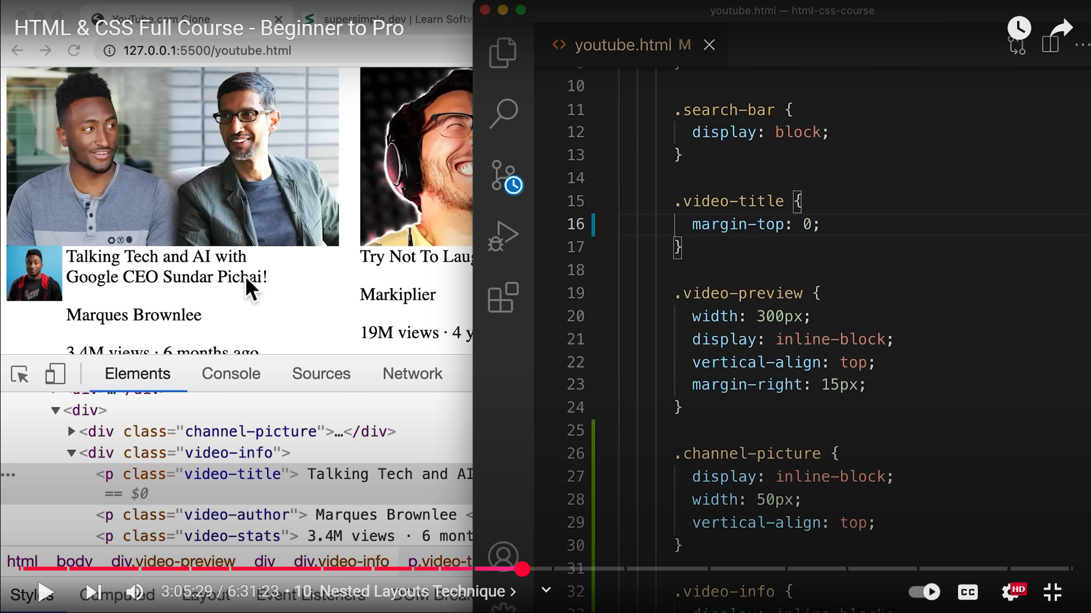  
16  
  
Now, we’ll just style as we have done the nested layout for this particular video.  
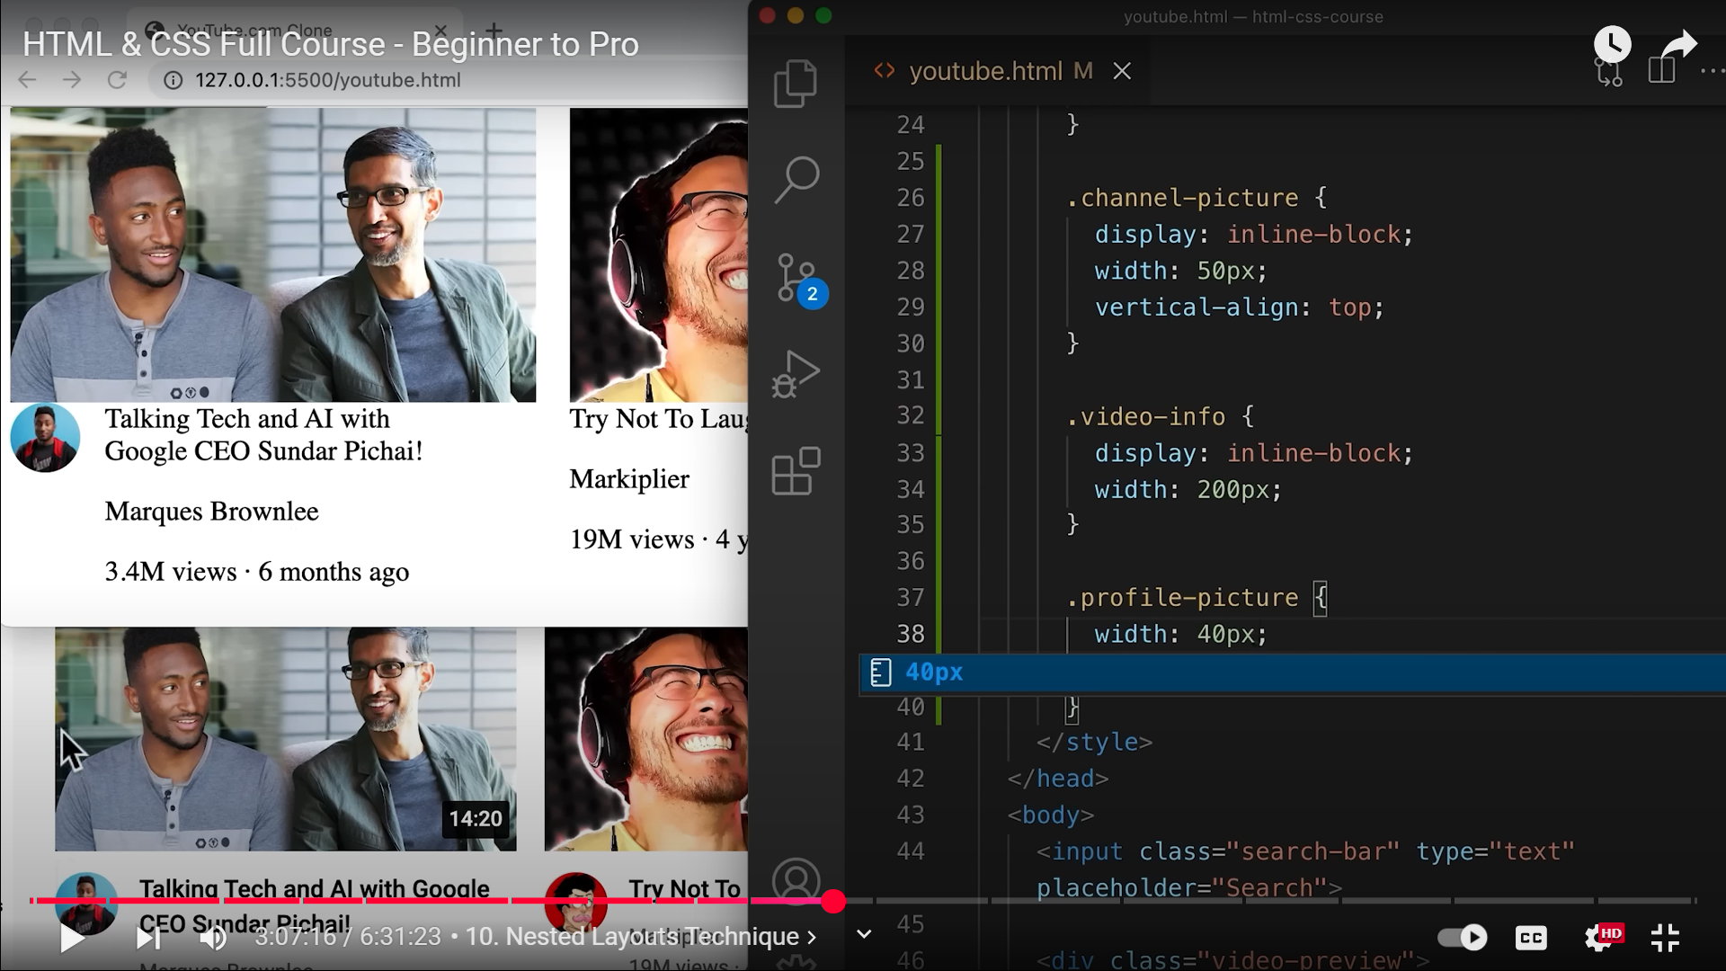  
38

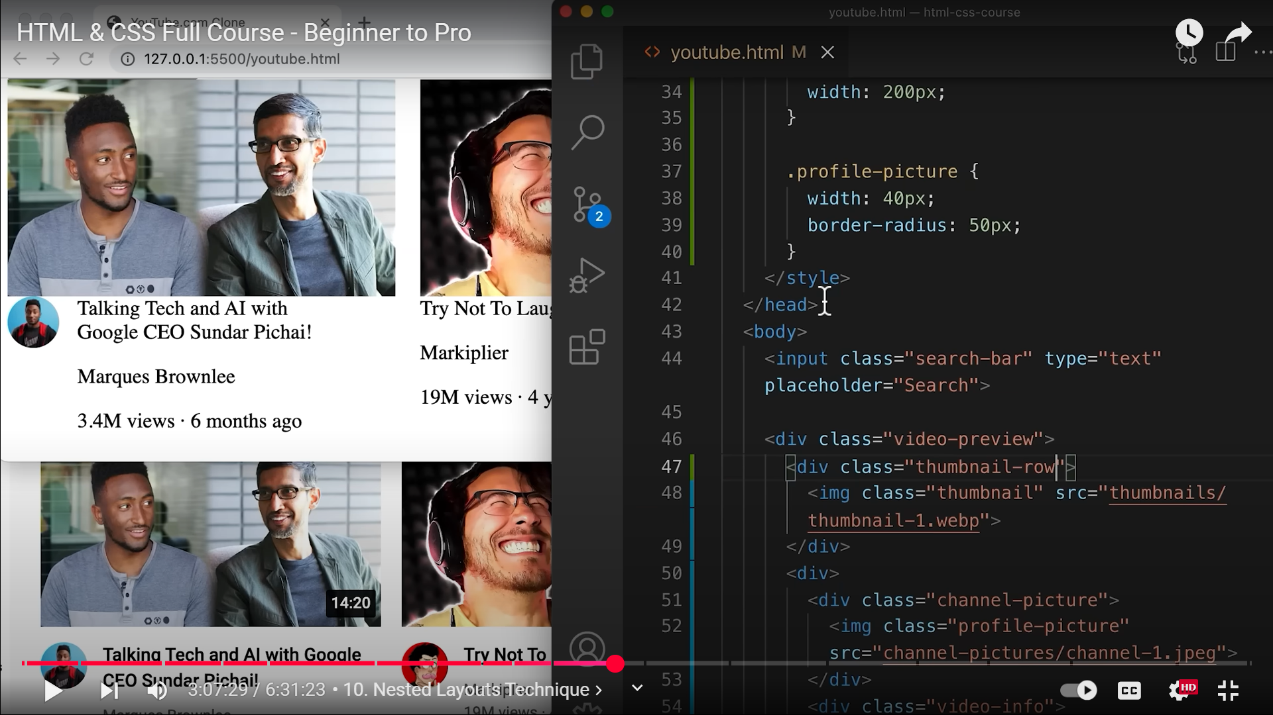  
47 class added  
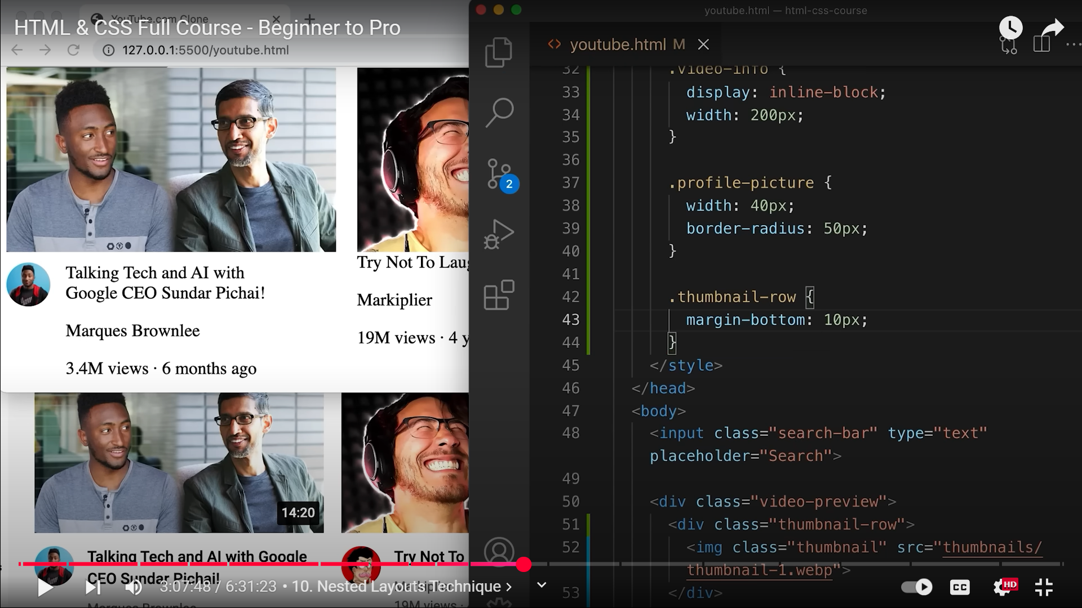  
43  
  
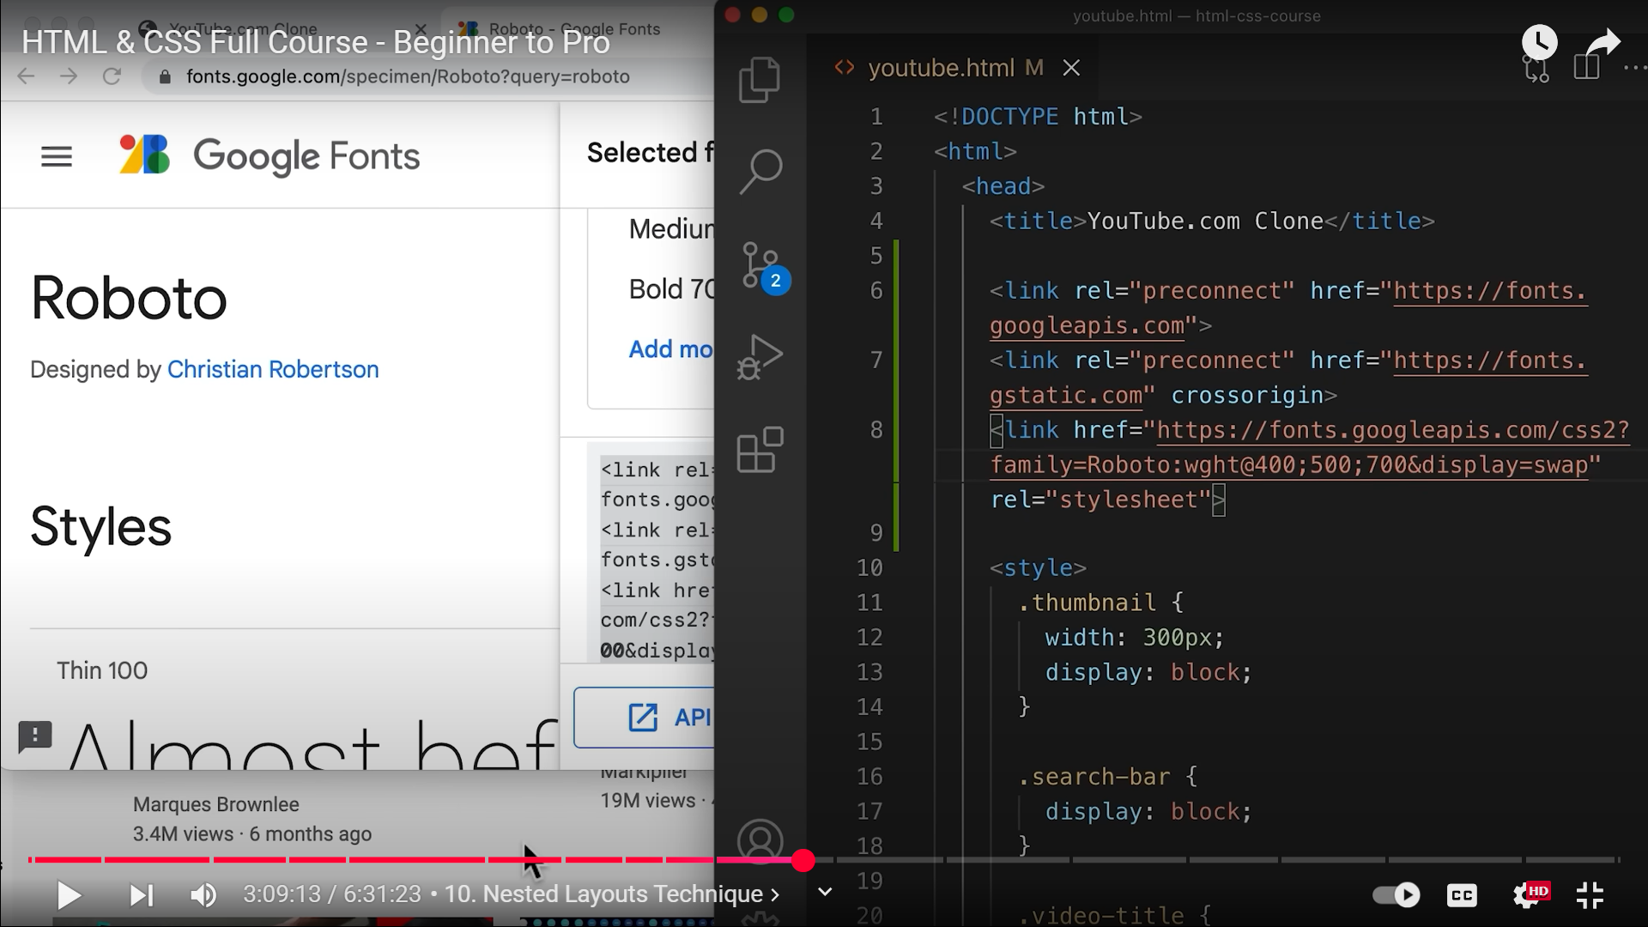  
font loaded into the page  
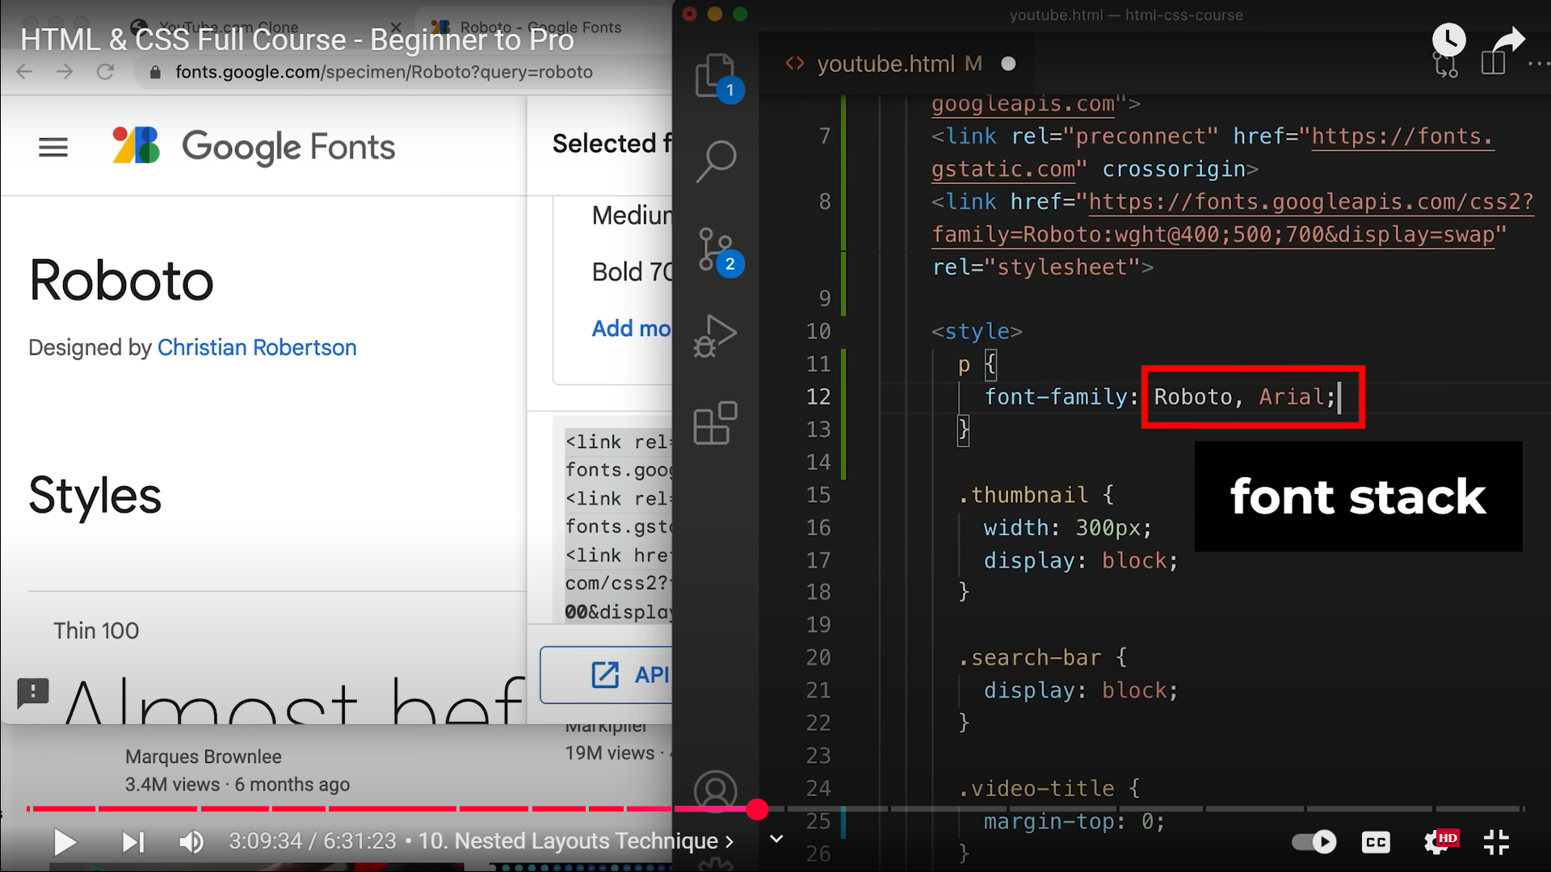  
11-13. Arial is the backup font if roboto fails to get loaded  
  
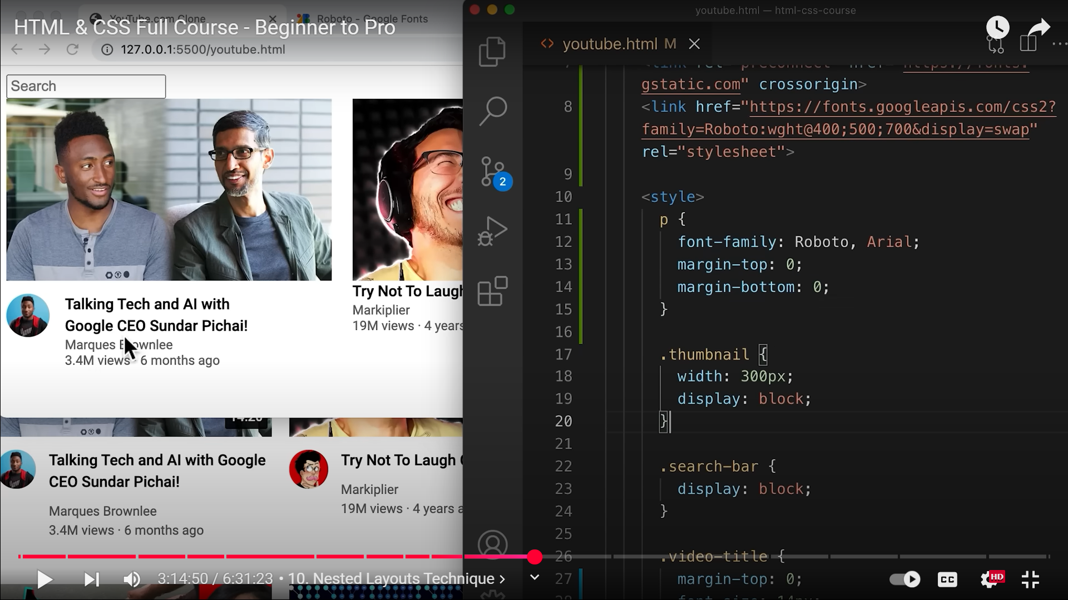  
13, 14 – getting rid of all default margins

